Friday 5th December 2025
This week in Reception:

St George’s Church/Road Safety
This week we visited St George’s Church. In the lead up to the visit we talked about Churches, why people go to church, what occasions take place in a church and things you might find inside a church. We also talked about road safety, as it was the first time Reception were leaving the school on a class visit. The children remembered what they learned from PC Andrea – Stop! Look! Listen!
We were very impressed with the children’s listening and how well they coped on their first trip! They were sensible walking to and from the Church and remembered the road safety rules. The children really enjoyed listening to Richard and learning about the story of Christmas and different parts of the church. We have sent a big thank you to Richard for giving up his time to meet the classes.
Thank you so much to all the parents who volunteered for the visit, we could not give these experiences without you and your support is so appreciated!

Stay and Play
Thank you to everyone who came to our Stay and Play this morning, the children so enjoy having you in the classroom!
Please note that at the end of the Stay and Play you must exit the school via the gate on Elsinore Road. If you walk through any gates that are closed and locked, please ensure that the gates are then closed and locked behind you.
When exiting the gate please do not let anyone in through the gate from outside, they would need to buzz through to the office first - this is a safeguarding measure.
Thank you for your understanding.

Labelling belongings A gentle reminder to please label all your child’s belongings with their name. If your child has lost something, please check the lost property shed.

Cold Weather Now that the weather is colder, please ensure your child has adequate clothing for time spent outside. We suggest gloves, hat, scarf, coat and warm/waterproof shoes or boots.

Bookbags and Reading
Your child’s bookbag will come home on a Thursday
Please bring their bookbag into school on a Monday
This is important so that we can put all reading books back into their packs ready to give out new books for the week.
Please note that the children will now not be bringing home a reading book next week or over the holidays.
This is because next week we will conduct our phonics assessments during reading time and we need to collect in all the books so that we can re-organise them ready to start again in January.
Most importantly, the children deserve a break and to enjoy their holidays!

Phonics
This week in Phonics the children have been revisiting all the sounds they have learned so far, with a focus on j,v,w,x,y,z,qu,ch,sh,th,ng,nk.
We continue to practise recognising and reading the tricky words; I, the, is, as, full, put, pull, and, has, his, her, go, no, to, into, she, he, of. They have also learnt the new tricky words we, me and be.
This week the focus has been reading words with ‘s’ at the end.. bags, dogs, shells, rings, zips and more.

At home you could play the following interactive phonics games:
PhonicsPlay Obb and Bob, Dragons Den or Picnic on Pluto
Balloon Phonics: Three-Letter Words CVC Game

Maths
This week we focused on Number Recognition, the children have been discovering that numbers are everywhere on buses, remote controls, clocks and more! the children have enjoyed finding numbers in the environment and have been practising recognising numbers 1 to 5 as well as matching each number to the same amount.
The children have also been practising writing numbers 1 to 5.
The children have enjoyed the following game and song!
Helicopter Rescue - Mental Maths for 4 to 8 Year Olds
Let's Learn Our Numbers 0-10 | Counting Song for Kids | Jack Hartmann Writing Numbers
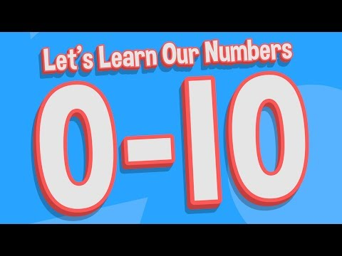
Important Dates
- Christmas jumper day and Christmas lunch – Friday 12th December
- Reception Christmas Performance – Thursday 18th December 9.30am and 2.15pm
- Last day of term – Friday 19th December – 2pm finish

Home learning ideas:
- Go on a number hunt around your home/or local area – which numbers can your child spot?
- Play card games, dominoes or complete a jigsaw with your child this is great for practising turn taking, problem solving and developing language.
- Practice putting on gloves – many of the children are more confident with putting their coats on in the cold weather but many still find it hard with their gloves so extra practice would be great.
We need your help!
Please help us to collect these items; we are having a competition between the classes! These items are to contribute to OPAL (Outdoor Play and Learning) please bring them to your child’s classroom or the main playground by the sheds.



